

SMS Monitor User Guide

Disclaimer

Copyright © 2000 - 2005 Chicago Board Options Exchange. All rights reserved.
The information contained in this document constitutes confidential and/or trade secret information belonging to CBOE. This document is made available to CBOE employees. This document is provided "As Is" with all faults and without warranty of any kind, either express or implied.

Points of Contact

If you have any questions or review comments about this document, please contact Deepak Manohar at (312) 786 8847.

Table of Contents
Table of Contents iii
Introduction v
Purpose v
Intended Audience v
Support and Questions v
Document Organization v
Section 1: Application Launch 1
Getting Started 2
Start Menu 2
Section 2: SMS Event Details 3
Screen Layout 4
Modifying the layout 5
Resize Panel Size 5
Hide/Unhide Filter Panel 6
Hide/Unhide Data Panel 7
Applying a Filter 8
Displaying all Events 8
Filtering Events 9
Clearing Filters 9
Modifying Existing Filter 9
Filtering Events by Grouping 10
Filtering Events by Timeframe 10
Filtering Events by Event Type 13
Changing Event Order 14
Displaying Event’s Origin Details 15
Section 3: SMS User Summary 17
Screen Layout 18
Modifying the layout 18
Applying a Filter 19
Displaying all Summaries 19
Filtering Events 20
Clearing Filters 20
Modifying Existing Filter 20
Filtering Events by Grouping 20
Filtering Events by Timeframe 21
Changing Event Order 21
Displaying Event’s Origin Details 22
Section 4: SMS Cas Details 23
Screen Layout 24
Modifying the layout 24
Applying a Filter 25
Displaying all Origins 25
Filtering Events 26
Clearing Filters 26
Modifying Existing Filter 26
Filtering Events by Grouping 26
Changing Event Order 27

Introduction

Purpose | This user manual contains all essential information for the user to make full use of the Session Browser system. This manual includes a description of the system functions and capabilities, contingencies and alternate modes of operation, and step-by-step procedures for system access and use.
Intended Audience | This user guide is intended for anyone interested monitoring the trading sessions of the user’s of CBOEdirect.
Support and Questions | Questions regarding this document can be directed to The Chicago Board Options Exchange at (312) 786 7300 or via email at cboedirectsupport@cboe.com.

Document Organization | The SMS Monitor was designed to monitor CBOEdirect users’ trading sessions. It makes uses of real-time session data for the information shown in the screens. Information on some screens is constant and does not change.  The document contains the following main sections:

 | Section 1:  Application Launch

This section describes the startup procedure for the SMS Monitor.

Getting Started

When you launch the SMS Monitor application the following toolbar will be displayed along the top of the screen. This menu bar cannot be resized, but can be moved to any point of the screen and minimized to the windows task bar.
- Note: This application has been designed to run on the Microsoft Windows platform and has been tested in this environment. Its compatibility with other operating systems has not been determined.
Start Menu | This menu acts as the starting point for all modules of the application. All the three modules are launched using this menu. The menu and its items can be accessed via the mouse or keyboard (using shortcut keys).  Activation: Left click on “Start” or use the “Alt+S” keyboard shortcut.
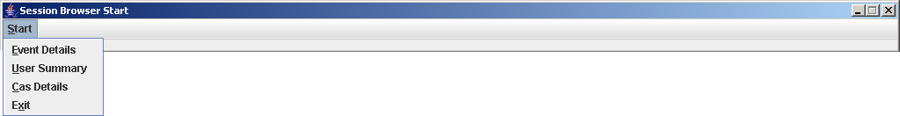
The Event Details menu item triggers the launch of the SMS Event Details module, which displays all session events. Further details on this module can be found in Section 2.
Activation: Left click on the “Event Details” menu item or use the “Alt+E” keyboard shortcut.
The User Summary menu item triggers the launch of the SMS User Summary module, which displays all session events, grouped by user. Further details on this module can be found in Section 3.
Activation: Left click on the “User Summary” menu item or use the “Alt+U” keyboard shortcut.
The Cas Details menu item brings up the SMS Cas Details module, which displays detailed information about all the Cas machines. Further information about this module can be found in Section 4.
Activation: Left click on the “Cas Details” menu item or use the “Alt+C” keyboard shortcut.
The Exit menu item terminates the application.
Activation: Left click on the “Exit” menu item or use the “Alt+X” keyboard shortcut. The application can also be terminated using the standard windows control available in the right-hand corner of the title bar.

 | Section 2:  SMS Event Details

This module gives the details of all events that have occurred in the CBOEdirect trading system. The data displayed is real-time in nature and is extracted from a log that is constantly updated.
This section describes in detail the SMS Event Details module, including screen layout, functions and description of data displayed.

Screen Layout

When you launch the SMS Event Details module via the start menu, the following screen is displayed.
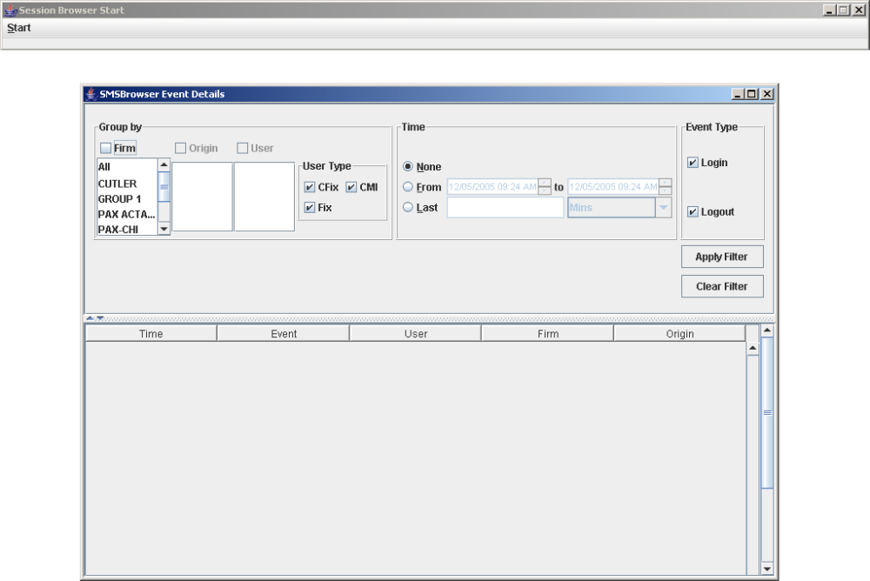
Note that this launches as another application and the startup toolbar is still available.
On startup no data is displayed. A filter must be applied to show any data. This has been explained in a subsequent section.
The screen primarily consists of the following two sections:
  - Filter Panel: This contains the controls that allow you to constrain the data displayed in the data panel. It allows you to specify whether you want to see the entire data set or a restricted view.
  - Data Panel: This shows all the event data as defined by the filter panel in a tabular format.
Details of the filter controls and table fields are given in the next section.

Modifying the layout | A split pane (horizontal bar in the middle) separates the two panels. This bar contains two controls at its left-hand corner – an arrowhead pointing up and another pointing down.

Resize Panel Size
To resize the panels left click on the split pane and while keeping the mouse button pressed drag the mouse towards the top or bottom. Dragging it towards the top reduces the space occupied by the Filter panel and simultaneously increases the space occupied by the Data Panel. As seen below, scroll bars appear to allow you to scroll and view items that have become hidden due to the resizing.
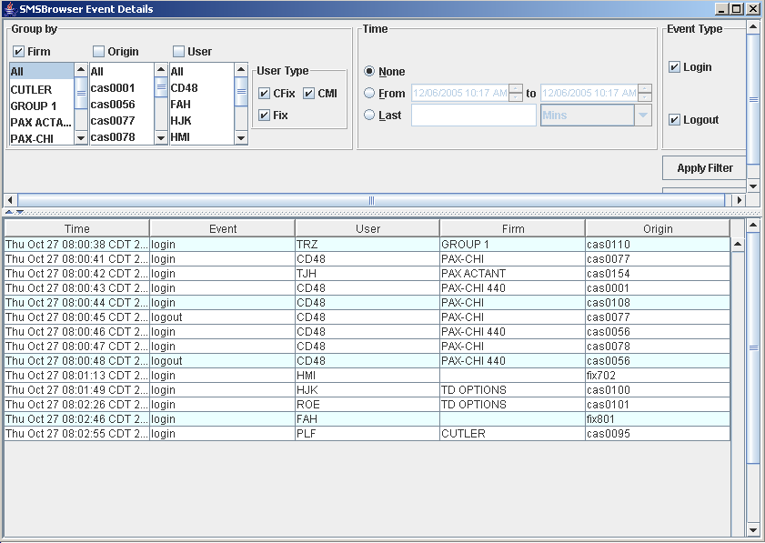

Hide/Unhide Filter Panel
Left-click on the arrowhead pointing upwards. This will hide the Filter panel and only the Data panel will be visible. The split pane will have been relegated to the top of the window just below the title bar.
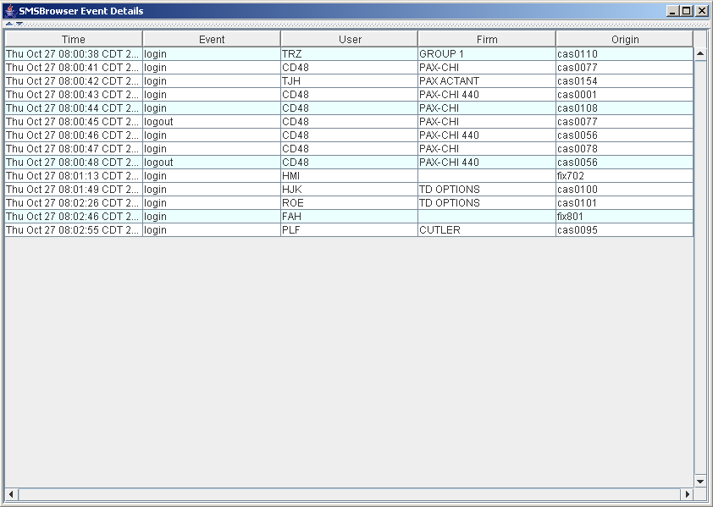
 | Now, to unhide the Filter panel left-click on the arrowhead pointing down. The panel would be restored to the same size as it was before hiding it.

Hide/Unhide Data Panel
Left-click on the arrowhead pointing down. This will hide the Data panel and only the Filter panel will be visible. The split pane will have been relegated to the bottom of the window.
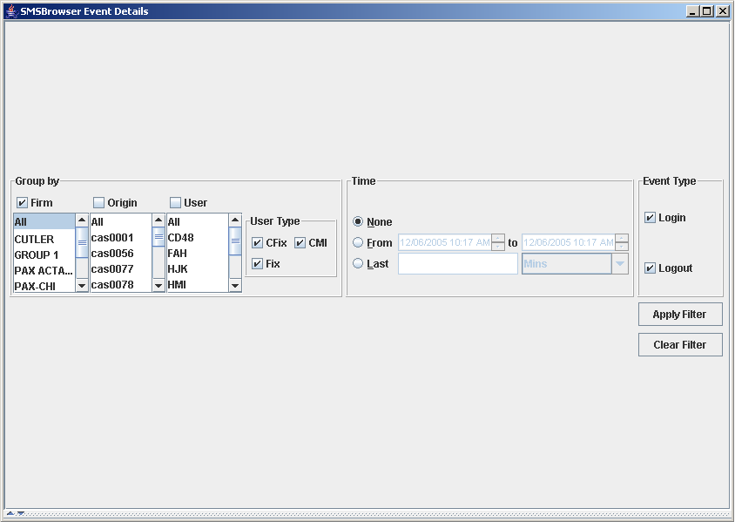
Now, to unhide the Data panel left-click on the arrowhead pointing up. The panel would be restored to the same size as it was before hiding it.

Applying a Filter

 | This section describes the use and operation of the Filter and Data panels.
Displaying all Events | To display any data in the Data panel you have to apply the appropriate filter. To show all the events that have occurred without any constraints follow the procedure described below.
 | - Select “All” from the Firm list in the “Group By:” section of the Filter panel. The Origin and User list will be populated with all the Origins available and all the Users whose activity data is currently in the log.
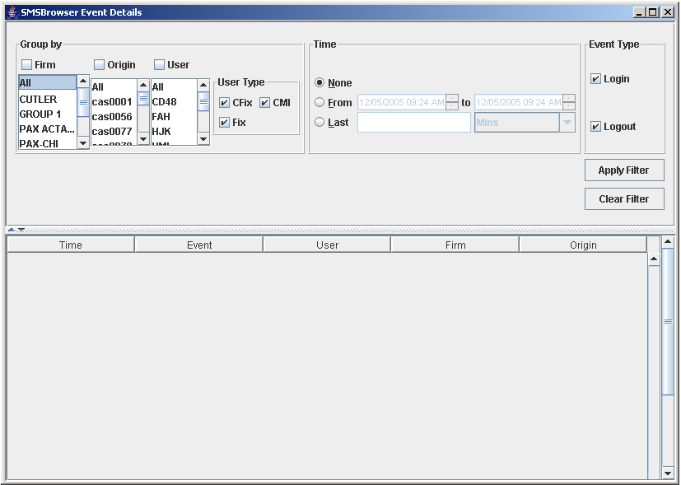
- Before applying the filter you must decide whether you want the events to be searched for by Firm, Origin or User. If searching by firm, then check the Firm checkbox above the Firm list. If searching by origin, then check the Origin checkbox above the Origin list. If searching by user, then check the User checkbox above the User list.
- Left-click on the “Apply Filter” button. All the events that have taken place will be displayed in the table. Any event that occurs after this point will simply be added to the table as another row.
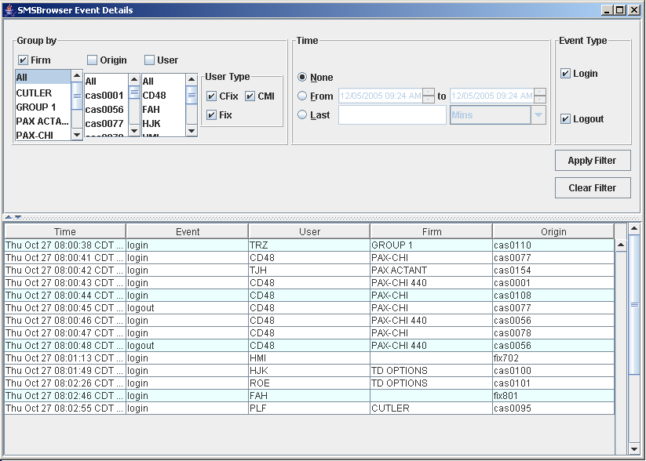
 | By default the events are ordered by time, i.e. when they occurred starting from the earliest event to the latest one.
Filtering Events | The events displayed can be restricted using the Filter panel.

Clearing Filters

After a filter has been applied any new event that occurs will first be matched against the filter constraints before being published to the table. As such only those events will be displayed that continue to match the applied filter.
To clear an applied filter just left-click on the “Clear Filter” button on the Filter panel. This will clear the table of all records and reset the Filter panel to its startup state.

Modifying Existing Filter

An existing filter that has been currently applied on the data can be modified in one of two ways.
First method is to clearing all filters using the method described above and then applying a new filter. Alternatively, changing the filter constraints of the existing filter and then applying it by left clicking on the “Apply Filter” button can also apply a new filter. This would remove the previous filter and all event data current and future will be matched against this. Each of these filter constraints has been explained below.

Filtering Events by Grouping

The “Group by:” subsection in the Filter panel contains the following components:
  - Firm list: contains a list of all firms.
  - Origin list: a list of all origin machines.
  - User list: a list of all users whose data is currently available.
Note that the lists only contain those names whose data is currently available in the logs. This is not a comprehensive list of all possible values.
  - User Type checkbox group: This allows you to specify which category users you are interested in.
  - CFix users: users that are logged into CFix machines, either using or not using Fix engines.
  - Fix users: users that are using Fix engines.
  - CMI users: users that are using the CMI Interface (login from Cas machines).
Select a list item from the Firm list. This populates the Origin and Users list with all matching origin machines and users respectively. Multiple values can be selected as well. Simply press the “Ctrl” key on the keyboard and while keeping it pressed make additional selections in the list.
Making further selections in the origin list will further filter the users list. The users list is matched against checkbox selections made in the User Type checkbox group. One of the checkboxes will always be selected i.e. all the checkboxes cannot be unchecked at the same time.
After making your selections, check one of the checkboxes above the lists. Checking the firm checkbox will filter the events by the selected firms. Checking the origin checkbox will filter the events by the selected origins. Checking the user checkbox will filter the events by the selected users. Only one checkbox can be selected at a time.
If you are done with selections and do not want to apply other constraints such as Timeframe and Event Type, apply the filter by left-clicking the “Apply Filter” button. If you do then follow the instructions below.

Filtering Events by Timeframe

This function allows you to specify the time period for which you want to view the events.
Its default setting is “None” where no timing constraint is placed on the data set. The figure below shows the second setting “From” which allows you to specify a time range i.e. “From” and “to” date/time values to match against.
To use this setting follow these instructions:
  - Select the “From” radio button in the “Time” control group.
  - The time is specified in the format “mm/dd/yyyy hh:mm AM or PM”. Select the part of the time and use the adjoining spinner control to advance or reduce the value.
The figure shows that the minute field’s value is selected. The spinner control can be used to increase or decrease its value.
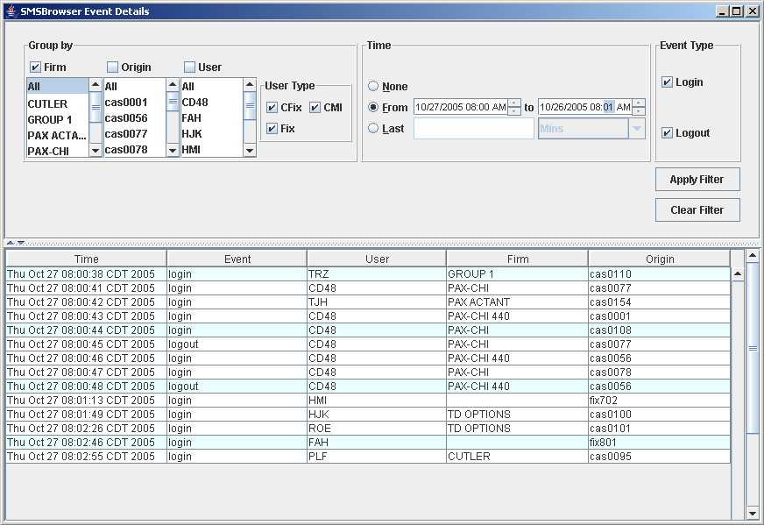
When this time range shown in the above figure is applied to the data set, the table changes to reflect the constraints. This change is shown in the next figure.
Applying of this timeframe constraint is analogous to applying a new filter and the procedure for doing so is the same as before.
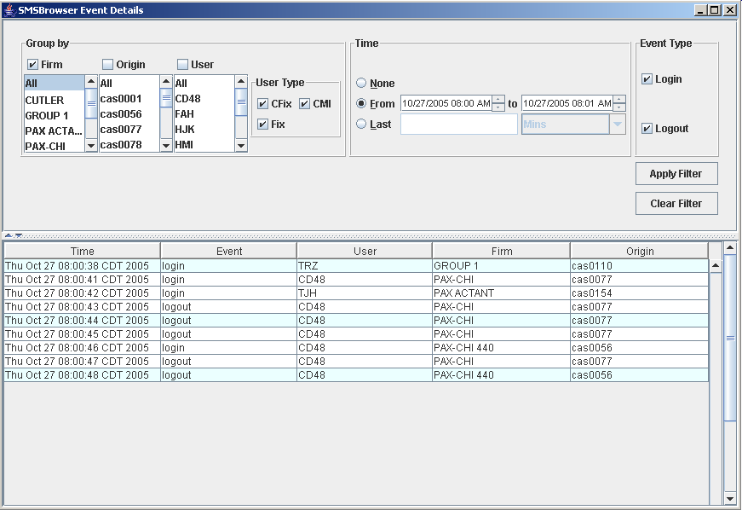
The third setting is the “Last setting”. Here there is a textbox allowing you to enter an integer value and select one of the two time units available in the drop-down list – “Mins” and “Hours”.
This allows you to filter for events that occurred for example in the last 50 minutes or last 50 hours. The procedure for applying this remains the same as before.
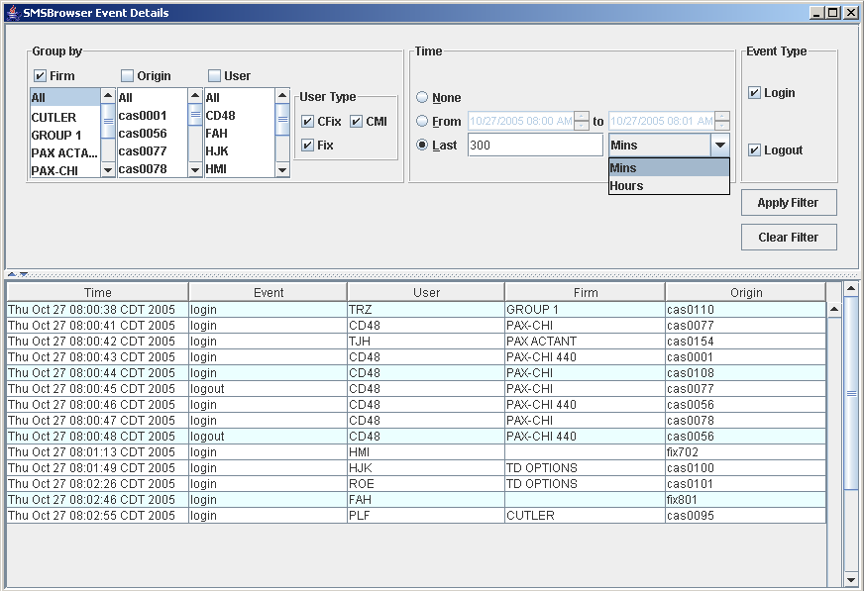

Filtering Events by Event Type

By default both login and logout events are published to the table. If required, you can view just one type of event as well.
To do so simply uncheck one of the checkboxes in the Event Type component group in the Filter Panel and left-click on the “Apply Filter” button. The “Clear Filter” button can be used to clear any applied filters before doing this if so required or it can be applied “as-is” to modify the currently applied filter.
Changing Event Order | By default the event rows are added to the table in the order in which they occurred. However, you can also change the ordering to any other field (Event, User, Firm or Origin) as well.  To do so simply left-click once on any field header and the rows will get ordered in ascending order. Clicking it again will change the ordering to descending.
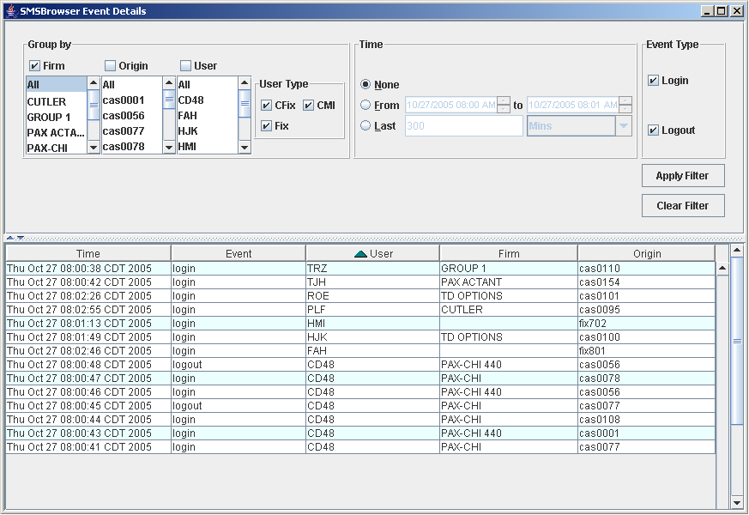

Displaying Event’s Origin Details

The table rows represent events each of which has an origin field. This is the name of the origin machine and further details about this machine can be viewed by a simple procedure.
Left-click on the row whose origin details you wish to view. The row gets highlighted in blue. Multiple rows can be selected as well. Simply press the “Ctrl” key on the keyboard and while keeping it pressed make additional selections in the list.
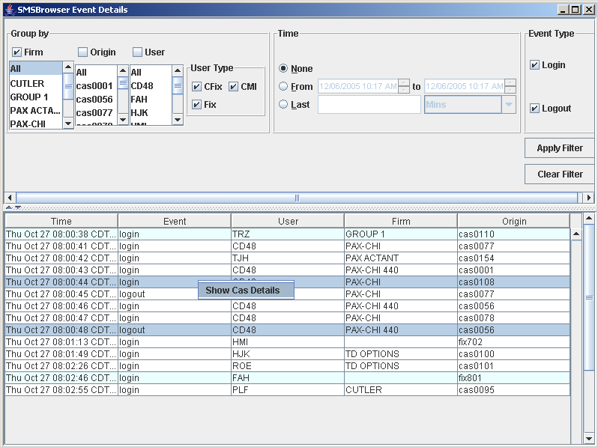
As can be seen in the figure above two rows have been selected. Upon right clicking on any one of the selected rows you will be presented with a popup menu containing one menu item called “Show Cas Details”.
Left clicking on this would generate the SMS Cas Details screen. This screen’s data panel would contain the same number of rows as selected here, each representing the details of a single origin machine.
This is shown in the following figure where a new window opens and displays the details of the two origin machines selected above.
Further details about this module and the table values can be found in Section 3: SMS Cas Details.
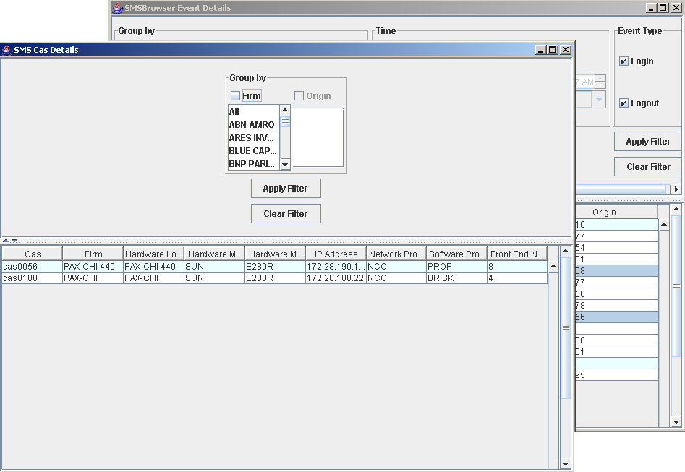

 | Section 3:  SMS User Summary

This module gives the summary of user activity. Each user’s details including the count of different events pertaining to each user is displayed. Each row represents a different user’s activity. The data displayed is real-time in nature and is extracted from a log that is constantly updated.
This section describes in detail the SMS User Summary module, including screen layout, functions and description of data displayed.

Screen Layout

When you launch the SMS User Summary module via the start menu, a screen similar to that of the SMS Event Details is launched.

The screen primarily consists of the following two sections:
  - Filter Panel: This contains the controls that allow you to constrain the data displayed in the data panel. It allows you to specify whether you want to see the entire data set or a restricted view. This is exactly the same as the filter panel present in the SMS Event Details screen with one difference. No Event Type component group is available here.
  - Data Panel: This shows all the event data as defined by the filter panel in a tabular format.
Modifying the layout | The operation to modify the layout is exactly the same as that of the SMS Event Details screen. Please refer to the instructions provided in the corresponding section of Section 2: SMS Event Details.

Applying a Filter

 | This section describes the use and operation of the Filter and Data panels.
Displaying all Summaries | To display any data in the Data panel you have to apply the appropriate filter. To show all the events that have occurred without any constraints follow the procedure described below.
 | - Select “All” from the Firm list in the “Group By:” section of the Filter panel. The Origin and User list will be populated with all the Origins available and all the Users whose activity data is currently in the log.
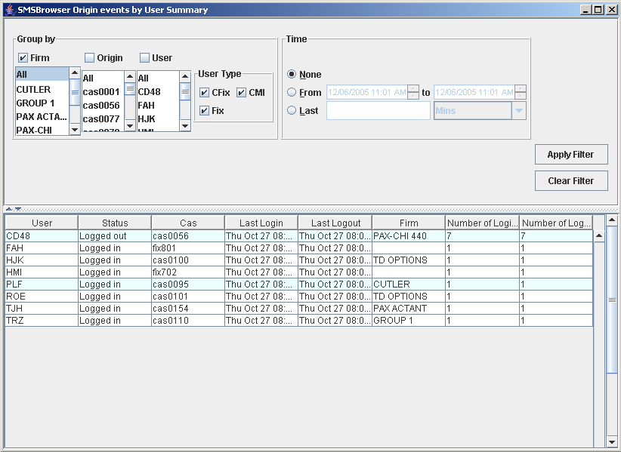
- Before applying the filter you must decide whether you want the events to be searched for by Firm, Origin or User. If searching by firm, then check the Firm checkbox above the Firm list. If searching by origin, then check the Origin checkbox above the Origin list. If searching by user, then check the User checkbox above the User list.
- Left-click on the “Apply Filter” button. All the events that have taken place will be displayed in the table grouped by user. Any event occurring would now simply modify the event count of the corresponding user or would add a new row if the user is not already in the table.
Each user is represented by a single table row. The table basically gives the following information concerning each user:
  - User: the user’s name
  - Status: whether the user is logged in to system or not at present.
  - Cas: the machine the user is using.
  - Last Login: when the user’s last login event was recorded.
  - Last Logout: when the user’s last logout event was recorded.
  - Firm: which firm the user belongs to.
  - Number of logins: the total number of login events that have been recorded so far.
  - Number of logouts: the total number of login events that have been recorded so far.
Filtering Events | The summaries displayed can be restricted using the Filter panel.

Clearing Filters

Same as SMS Event Details.

Modifying Existing Filter

Same as SMS Event Details.

Filtering Events by Grouping

Same as SMS Event Details. An example operation has been illustrated in the next figure.
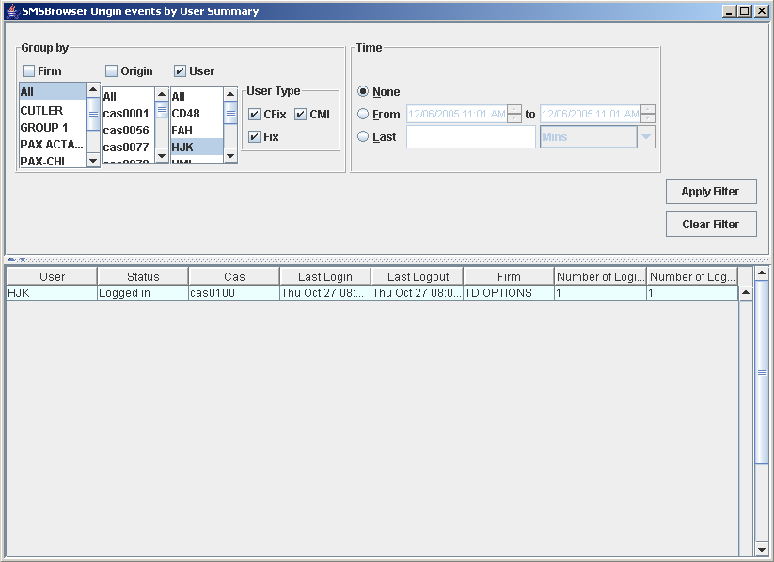

Filtering Events by Timeframe

This function allows you to specify the time period for which you want to view the events.
The operation remains the same as in SMS Event Details. The effect of this filter in this case is that the data shown for each user would now reflect the time range specified.
 | For example, the values for number of logins and logouts would reflect the occurrences of these events during that time period.
Changing Event Order | This remains similar in operation to the SMS Event Details module. Clicking on the column headers sorts the table rows by that field.

Displaying Event’s Origin Details

The procedure for this also remains exactly the same as SMS Event Details
Left-click on the row whose origin details you wish to view. The row gets highlighted in blue. Multiple rows can be selected as well. Simply press the “Ctrl” key on the keyboard and while keeping it pressed make additional selections in the list.
A right click on any of the selected rows shows the same popup menu described earlier.
Clicking on this would generate a Cas Details screen containing the details of the origin machines in the selected rows as before.

 | Section 4:  SMS Cas Details

This module provides the details of the all origin machines (Cas & fix). Each machine is represented by a separate row of the table.
This section describes in detail the SMS Cas Details module, including screen layout, functions and description of data displayed.
This module can be launched via the Start menu on the startup bar or from inside the other modules.

Screen Layout

When you launch the SMS Cas Details module via the start menu, a screen similar to that of the SMS Event Details is launched.

The screen primarily consists of the following two sections:
  - Filter Panel: This is a much-restricted version of the filter panels available in the other two modules. Only a “Group by” component group is available with two lists Firm and Origin.
  - Data Panel: This shows all the origin data as defined by the filter panel in a tabular format.
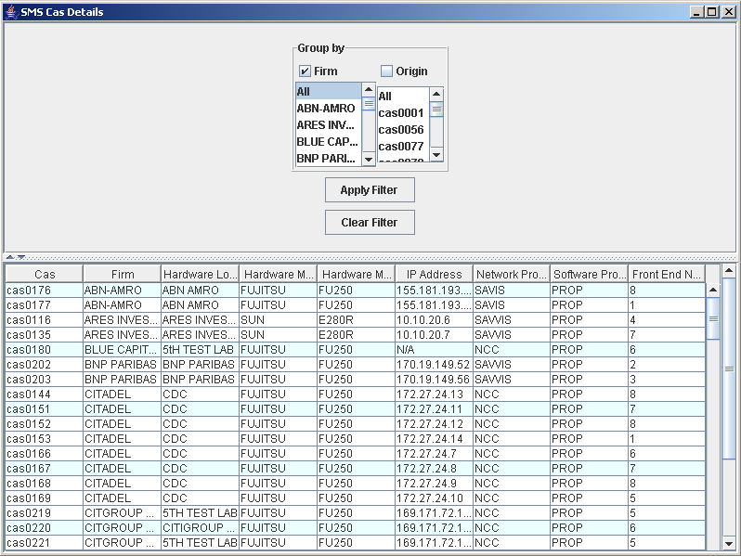
Modifying the layout | The operation to modify the layout is exactly the same as that of the SMS Event Details screen. Please refer to the instructions provided in the corresponding section of Section 2: SMS Event Details.

Applying a Filter

 | This section describes the use and operation of the Filter and Data panels.
Displaying all Origins | To display any data in the Data panel you have to apply the appropriate filter. To show all the events that have occurred without any constraints follow the procedure described below.
 | - Select “All” from the Firm list in the “Group By:” section of the Filter panel. The Origin list will be populated with all the Origins available.
    - Before applying the filter you must decide whether you want the data to be searched for by Firm or Origin. If searching by firm, then check the Firm checkbox above the Firm list. If searching by origin, then check the Origin checkbox above the Origin list.
    - Left-click on the “Apply Filter” button.
Each origin machine is represented by a single table row. The table basically gives the following information concerning each machine:
  - Cas: the machines unique name/number.
  - Firm: the firm using the machine.
  - Hardware Location: the machine’s physical location
  - Hardware Manufacturer: the manufacturer of the machine.
  - Hardware Model: the model name/number of the machine.
  - IP Address: the machines unique IP address.
  - Network Provider
  - Software Provider
  - Front End number: the number of the Front-end machine being used.
Filtering Events | The origin details displayed can be restricted using the Filter panel.

Clearing Filters

Same as SMS Event Details.

Modifying Existing Filter

Similar to SMS Event Details.

Filtering Events by Grouping

Similar as SMS Event Details. An example operation has been illustrated in the next figure.
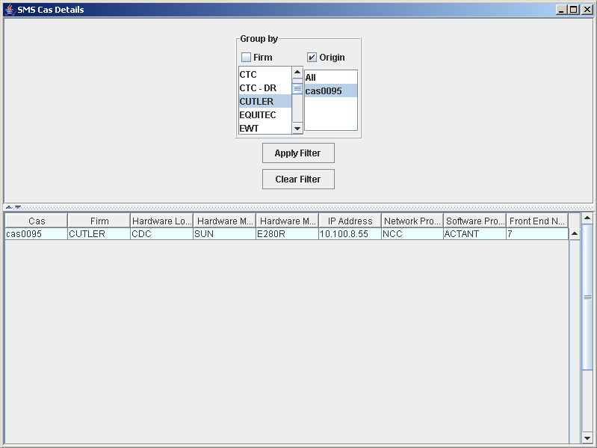
Changing Event Order | This remains similar in operation to the SMS Event Details module. Clicking on the column headers sorts the table rows by that field.

